Final Project Part 1 Optimization Technique and Implementation Project Report

Akshay Singh
Department of IT, University of the Cumberlands
Algorithms and Data Structures
Dr. Michael Solomon
August 15, 2026

Optimization in High-Performance Computing: Data Structure Optimization and Data Locality
Introduction
Solving computationally intensive problems that demand a large amount of data to be processed efficiently is achieved by high-performance computing (HPC). Common applications of HPC include in the fields of scientific and engineering applications like climate modeling, cancer research, drug discovery, nuclear energy, automotive design, and many more. From the empirical study by Azad et al. (2023), I learned that very high performance is hard to achieve in these applications due to the requirement for HPC software to enable efficient interaction with complex hardware architectures, memory systems, algorithms, and parallel programming models. The authors describe the various types of HPC applications that run on multicore CPUs, GPUs, and accelerators, where inefficient application implementation may add considerable overhead for performance.
In this work my focus was on optimizing data structure by optimizing the data locality. I chose this technique because it is directly connected to the organization and access of data in memory. If in HPC, a program has a theoretically efficient algorithm, it is no better if it accesses memory inefficiently. The empirical study shows that data locality is one of the critical root causes of HPC performance problems and lists 42 performance-fix commits that relate to data-locality optimization. Of these, seven were dedicated to optimization of data structures.
Overview of the Empirical HPC Performance Study
An Empirical Study of High Performance Computing (HPC) Performance Bugs by Azad et al. (2023) is the prime study used for this project. This study examines performance issues of real-world open-source HPC applications. While hardware complexity, inefficient algorithms, compiler generated code and inefficient parallelization are some of the obstacles to satisfy the two goals of HPC, namely, performance efficiency and scalability, the authors explain.
The researchers designed an empirical technique for the detection and study of performance bugs in HPC. They chose 23 open source HPC projects from various fields such as scientific computing and other HPC domains. They started by scanning for performance-related commits using performance-related keywords, and then manually checked the commits to find 1,729 potential performance-related commits. This process led to 186 confirmed performance commitments.
Table 1
Overview of the Empirical Study
Study Component | Result
HPC projects investigated | 23
Potential performance commits | 1,729
Confirmed performance commits | 186
Performance bug categories | 10
Largest optimization category | Microarchitecture-specific optimization
Data-locality optimization commits | 42
Data-structure optimization commits | 7

Four major research questions were explored in the study. The first question looked at why performance inefficiencies occurred, the second question looked at how to optimise performance problems, the third question looked at how much effort a developer had to put in to fix performance bugs and the fourth question looked at what skills a developer had to have in order to fix performance bugs.
3. HPC Performance Problems and Optimization Techniques.
The empirical study reveals that this can be due to various factors affecting HPC performance. These include bad algorithms and data structures, bad use of the hardware microarchitecture, concurrency and synchronization issues, memory-management issues, and other inefficiencies. Memory and data locality is one of the important categories. Before accessing main memory, modern processors have several levels of memory including registers and cache levels. The study provides an explanation of registers, which are the fastest storage but have a limited capacity, and cache memories, which offer a larger capacity at a slightly higher access latency. Due to this hierarchy, efficient use of memory and cache is significant in terms of achieving HPC performance. The study has come up with a number of optimization methods. These were the optimizations that were considered: better cache and memory locality, re-ordering memory references, minimizing global memory accesses, better utilization of registers and cache through blocking, storing frequently used data in registers, and using prefetching or memory pinning.
4. Optimizing Data Structures for Selected Optimization Technique:
As a technique, I used data structure optimization by locality of data. I decided to use this technique because it has a direct mapping between software design and hardware performance. The empirical study revealed that seven of the performance-related fixes for data structures were the inefficient data-structure libraries. One such example was TileDB, in which performance was disappointing due to a poor locality of data implementation in the forward_list data structure, which was a linked list, versus using a cache-efficient data structure such as vector. There is also a discussion on contiguous vs linked data structures. The objects in a std::vector and std::array are stored in adjacent memory locations, so these containers are more cache-friendly if they are accessed sequentially. On the contrary, std::list is a doubly-linked list, and its traversal may cause worse cache behaviour. One of the authors states that the performance improvement was observed when making a list to a vector, and that this was a CGAL performance fix.
5. Data Locality and Cache Performance
Data locality is the access to data in memory by a program. There are two important concepts: spatial locality, and temporal locality. Spatial locality states that if a program references a memory location, it is likely to reference nearby memory locations shortly afterwards. Temporal locality: if data is accessed recently, it will be accessed again.
Earlier studies into cache locality have indicated that processors can gain significantly, if programs have good data-access characteristics. describe the idea of cache memories as being to mitigate the performance difference between processor speed and memory speed, and they work best when there is data locality in the application. Their work explored the compiler transformations that can enhance spatial and temporal reuse of cache lines.
Data locality optimization who were successful in creating transformations to increase locality in nested loops. They showed that the transformations of loop interchange, reversal, skewing and tiling could enhance locality for scientific computation. Another important illustration of the significance of memory hierarchy is the cache-oblivious algorithms. They are aware that each level of cache possesses different performance properties, and design algorithms that make the most of the hierarchy, without relying on the programmer to explicitly set the cache parameters.
6. Strengths of Data Structure Optimization
There were a few good things I learned about optimising data structures in this project. Optimization of data structure: memory locality can be improved. Sequential access can be more efficient with cache lines when data is stored in a sequential and contiguous way.
Secondly, it can enhance the performance without altering the mathematical computation itself. In my implementation both versions give the same sum. I did not change the math problem, but changed the organization and access to the values. Third, the technique could be relatively simple to implement. The empirical study gives actual examples on how the developers transformed inefficient list structures to cache-friendly structures. Fourth, the technique has the ability to be applied to many computational workloads. Arrays, matrices, vectors, and other collections of data are often used in scientific programs for processing, and therefore, memory organization is important. Lastly, previous work showed that exploiting locality of reference is essential to high performance on modern processors, and data and loop transformations are likely to significantly increase cache performance.
7. Weaknesses and Limitations
While there are many advantages to optimizing data structures, I also found some drawbacks. One of the first constraints is that there isn't a single data structure that is the best for all applications. While a contiguous structure is very useful for sequential traversal, other operations may benefit from another structure. For instance, if the insertions or removals are frequent, there will be different performance considerations. The second restriction is that the performance gain is dependent on the workload. locality optimisations did not yield a consistent gain in performance across all applications. In some cases, the cache hit ratio of the programs was already very high, in other cases, it was optimized significantly. The third restriction, which I can't avoid, is that I wrote my implementation in Python. While it is helpful for demonstrating the concept, my experiment should not be taken as representative of the performance of a C++ program, a CUDA program, an OpenMP program or any production HPC program.
8. Implementation Methodology
For my implementation, I created a Python program called hpc_data_structure_optimization.py.
I designed the experiment around two data structures:
- Singly linked list — unoptimized implementation
- Python list — optimized implementation
I generated the same deterministic dataset for both implementations. The dataset contained consecutive integers beginning at 1. I then placed those values into both data structures.
The linked-list implementation contains individual Node objects. Each node stores a value and a reference to the next node. During traversal, the program starts at the first node and follows the next reference until the end of the list is reached.
The optimized implementation uses a Python list. Python's documentation describes lists as mutable sequences whose elements are commonly accessed through iteration. I used sequential iteration in both implementations so that the computational operation remained comparable.
The main calculation was:
Total = x1+x2+x3+……..+xn
I calculated the expected mathematical result separately so I could verify that both implementations returned the same answer.
9. Benchmarking Procedure
I used Python's time.perf_counter() to measure execution time. Instead of running each implementation only once, I repeated the benchmark five times for each dataset size. I then calculated the average execution time, minimum execution time, and standard deviation.
I tested multiple dataset sizes:
- 100,000 elements
- 250,000 elements
- 500,000 elements
- 1,000,000 elements
Testing several dataset sizes allowed me to examine whether the performance difference remained consistent as the amount of data increased.
I also calculated speedup using:
Speedup =T_Linked_List/T_ContiguousList
A speedup greater than 1 indicates that the contiguous-list implementation completed the operation faster than the linked-list implementation.
I calculated the percentage reduction in execution time using:
Reduction=(TLinked List​-TContiguous List)/TLinked_List×100
The program also verified that both implementations produced the same mathematical result before considering the performance comparison valid.
10. Implementation Analysis
My implementation demonstrates the same general optimization principle identified in the empirical study: the organization of data can affect performance because it influences memory-access behavior. The linked-list implementation requires the program to follow references from one node to another. Conceptually, the nodes can be located in different memory areas. This makes the access pattern less regular than sequential access through a contiguous structure. The optimized implementation uses a Python list and sequential iteration. This provides a more regular access pattern. The purpose of this design was to demonstrate the relationship between data organization, locality, and performance.
Figure 1
Conceptual Comparison of Data Structures
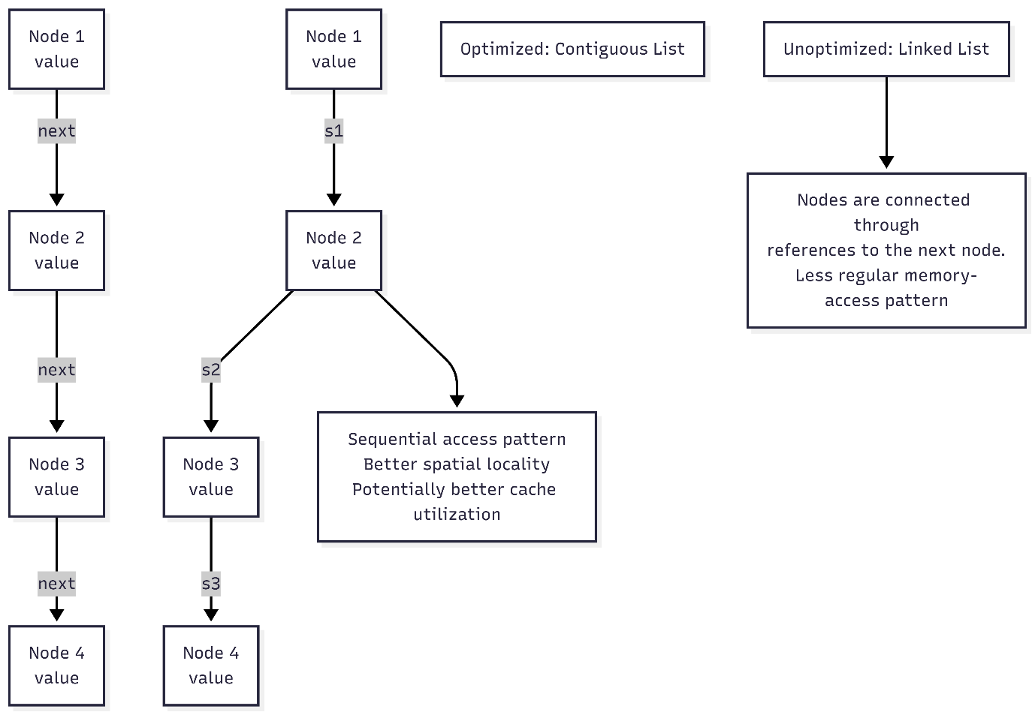

This conceptual relationship is consistent with the empirical study's discussion of data structures that promote regular memory access.
11. Performance Results
Important: I would insert the actual results generated by my Python program in this section rather than using theoretical or invented values.
Table 2
Performance Comparison
Dataset Size | Linked List Average (s) | Contiguous List Average (s) | Speedup | Time Reduction
1,00,000 | 0.004549 | 0.004335 | 1.05× | 4.72%
2,50,000 | 0.013192 | 0.01129 | 1.17× | 14.42%
5,00,000 | 0.02638 | 0.021206 | 1.24× | 19.61%
10,00,000 | 0.050135 | 0.041294 | 1.21× | 17.63%

I will use the results generated by my computer rather than assuming that the performance improvement will be a particular percentage. This is important because execution time depends on the computer hardware, operating-system activity, Python version, memory conditions, and other environmental factors. The experiment also verifies that both implementations calculate the same mathematical result. Therefore, the performance comparison is based on two implementations performing the same computational task.
12. Problems I Encountered
During the implementation process, I encountered several practical considerations.
The first challenge was designing an experiment that compared the data structures fairly. I needed both implementations to perform the same computational operation and use the same input values. I addressed this by generating one deterministic dataset and using that dataset to construct both structures. The second challenge was obtaining reliable execution-time measurements. A single measurement can be influenced by background processes and other activities occurring on the computer. I addressed this by repeating each benchmark five times and calculating the average. The third challenge was understanding the difference between a conceptual HPC optimization and a Python demonstration. The empirical study examines real HPC applications, while my implementation is a small-scale Python prototype. Therefore, I cannot assume that the magnitude of improvement in my program will match the improvements reported in the empirical study.
13. Comparison With the Empirical Study
My implementation supports the general principle described in the empirical study, but there are important differences between my experiment and the researchers' observations.
The empirical study analyzed real HPC applications and identified 186 confirmed performance commits across 23 projects. The authors found 42 data-locality optimization commits, including seven related specifically to data structures. The researchers also provided concrete examples. In one case, a linked-list data structure was replaced by a vector because of poor data locality. Another example involved changing lists to vectors to improve performance. My project follows the same basic idea by comparing a linked structure with a more contiguous structure.
14. Bug-Fixing Effort in HPC
Another important lesson I gained from the study is that HPC performance problems can be difficult to fix. The researchers compared 186 performance bugs with 186 non-performance bugs from their selected projects. They found that performance-bug fixes required approximately 80 lines of code on average, compared with fewer than 50 lines for non-performance bugs. Their Mann–Whitney U-test produced statistically significant results for patch size and the number of modified files. This finding helped me understand that optimization is not necessarily a simple process of changing one line of code. Developers may need to understand the algorithm, memory hierarchy, hardware architecture, compiler behavior, and application domain.
15. Lessons Learned
I learned several important lessons from completing this project.
First, I learned that data structures affect actual performance.
Before completing this project, I mainly considered data structures in terms of their algorithmic operations. This project helped me understand that the physical organization and access pattern of data can also affect performance.
Second, I learned that data locality is important in HPC.
A processor does not treat all memory accesses as equally expensive. Cache and memory hierarchy can significantly influence execution performance. demonstrates the importance of locality in scientific and high-performance applications.
Third, I learned that an optimization must be measured.
I should not assume that an optimized implementation is faster simply because it appears theoretically better. I used repeated benchmark measurements to evaluate the actual performance difference.
Fourth, I learned that the theoretical expectation and experimental result may differ.
The empirical study provides examples of substantial performance improvements in real HPC applications. My Python prototype is much smaller and operates in a different environment. Therefore, I learned that optimization results depend on workload, hardware, programming language, and implementation details.
16. Conclusion
In this project, I investigated optimization techniques used in high-performance computing and selected data structure optimization through improved data locality as the focus of my implementation. I selected this technique because the empirical study directly identifies data structure and data-locality optimization as important categories of HPC performance optimization. The study analyzed 1,729 potential performance commits from 23 HPC projects and confirmed 186 performance-related commits. It found 42 data-locality optimization fixes, including seven involving data structure optimization. I implemented a Python prototype comparing a singly linked list with a contiguous Python list. Both implementations performed the same sequential summation task, allowing me to focus the experiment on the effect of data organization and traversal. The project helped me understand that performance optimization is more than simply reducing the number of operations in an algorithm. The way data is organized and accessed can affect memory locality and processor-cache utilization. This concept is supported by both the empirical HPC study and previous research on cache and data locality.

References
Azad, M. A. K., Iqbal, N., Hassan, F., & Roy, P. (2023). An empirical study of high performance computing (HPC) performance bugs. 2023 IEEE/ACM 20th International Conference on Mining Software Repositories (MSR), 194–206. https://doi.org/10.1109/MSR59073.2023.00037 (NSF Public Access Repository)

Output
